Transaction Locks
Databases use locks to safely organize simultaneous transactions, preventing them from clashing when reading or writing data at the same time. A central lock manager controls which transaction gets access to specific data, which helps the system avoid deadlocks.

- Shared Lock (S-LOCK): A shared lock allows multiple transactions to read the same object at the same time. If one transaction holds a shared lock, then another transaction can also acquire that same shared lock.
- Exclusive Lock (X-LOCK): An exclusive lock allows a transaction to modify an object. This lock prevents other transactions from taking any other lock (S-LOCK or X-LOCK) on the object. Only one transaction can hold an exclusive lock at a time.
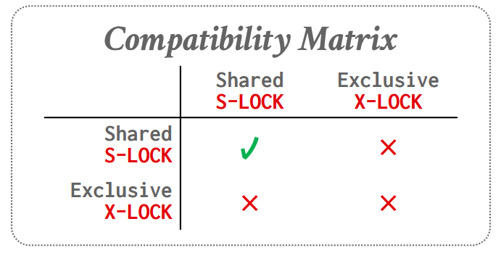

Two-Phase Locking
Two-Phase Locking (2PL) safely manages data access on the fly without needing to know a transaction's plan in advance. It works in two steps. First, in the "growing" phase, a transaction gathers all the locks it needs from the system. The moment it releases its first lock, it enters the "shrinking" phase, where it can only let go of locks and is completely forbidden from acquiring new ones.
While this strict two-step rule guarantees that transactions will execute safely, it has several drawbacks. It can artificially limit system performance, lead to deadlocks, and still allow uncommitted data to be read. It is also vulnerable to "cascading aborts," a costly chain reaction where one failed transaction forces others to completely undo their work.
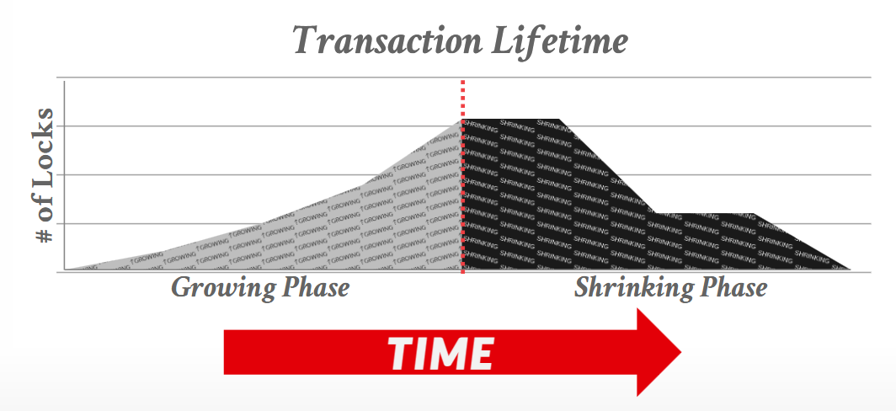

Strong Strict Two-Phase Locking
A schedule is "strict" if a transaction's changes are kept completely hidden from others until it is fully finished. The "Strong Strict 2PL" method ensures this by forcing a transaction to hold onto all of its locks until the very end. This completely prevents the costly domino effect of cascading aborts and makes it incredibly easy to undo mistakes, but holding locks for so long creates a bottleneck that limits overall system performance.
A slightly looser version, simply called "Strict 2PL," tries to speed things up by releasing its read locks early. While this allows more transactions to run at the same time, it unfortunately brings back the risks of reading unfinished data and triggering those chain-reaction aborts.
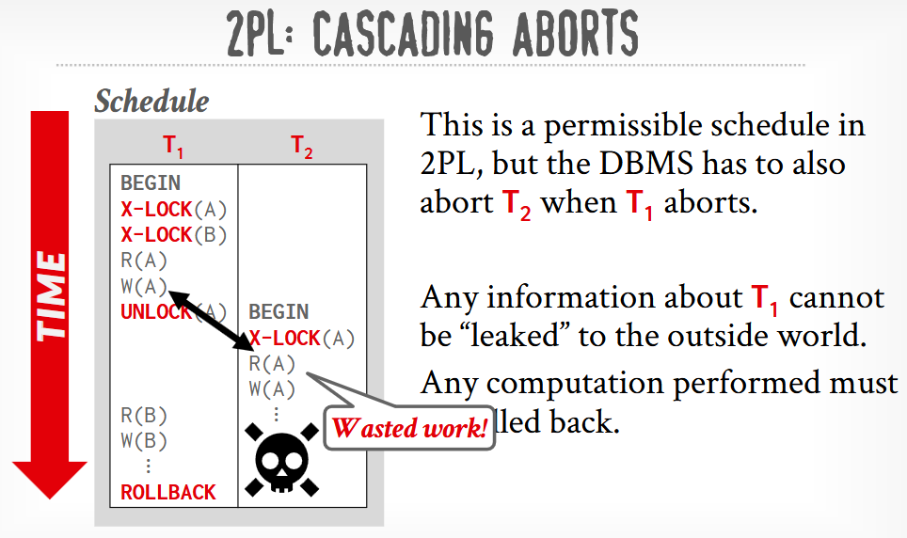

Deadlock Handling
- Deadlock Detection
To find deadlocks, the database builds a "waits-for graph," drawing an arrow from one transaction to another if it is waiting for a lock. A background process periodically checks this graph for loops. The system must carefully balance how often it checks: looking too frequently wastes computer power, but waiting too long leaves transactions stuck in a jam.
When a loop is found, the system breaks the deadlock by choosing a "victim" transaction to cancel. It selects this victim based on a mix of factors, such as how long it has been running, how much work it has completed, how many locks it holds, or how often it has been restarted in the past to prevent it from being unfairly targeted forever.
Once the victim is chosen, the database decides how much of its work to undo. It can either wipe out the entire transaction from scratch or just roll it back to a recent safe point—undoing only enough to break the deadlock and let the other transactions finish.
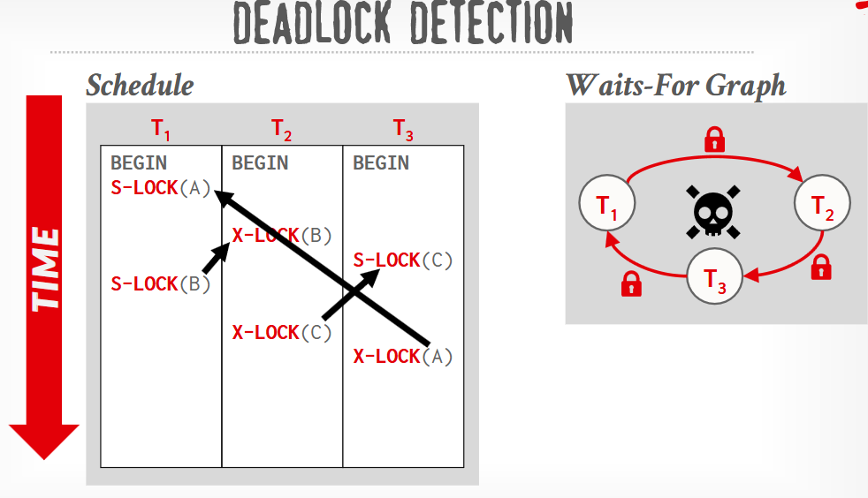

- Deadlock Prevention
Instead of waiting for deadlocks to happen, the system can prevent them entirely by assigning priorities to transactions based on their age. Older transactions get higher priority. When a transaction requests a lock already held by someone else, the database compares their ages and kills one to avoid a jam. To ensure fairness, restarted transactions keep their original age so they do not get permanently locked out.
There are two main rules to handle these conflicts. In the Wait-Die method, an older transaction will patiently wait for a younger one to finish, but a younger transaction is instantly aborted (dies) if it asks for a taken lock. In the Wound-Wait method, an older transaction aggressively aborts (wounds) the younger one to steal the lock, while a younger transaction must wait its turn.
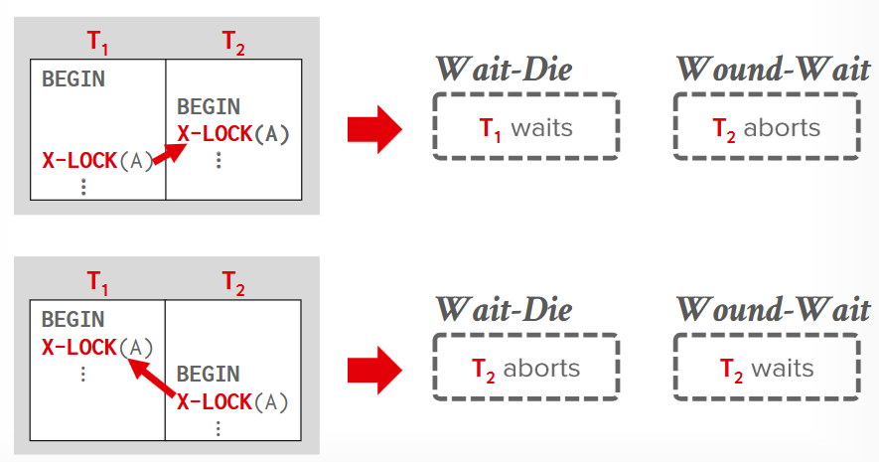
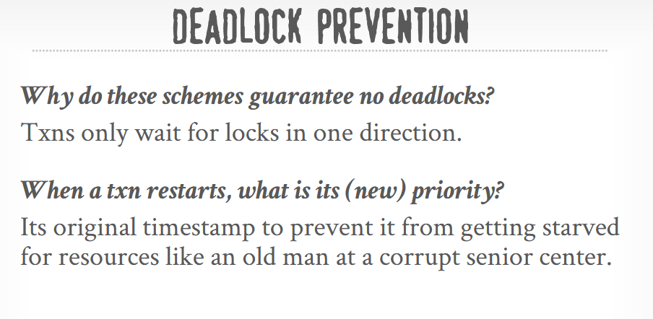
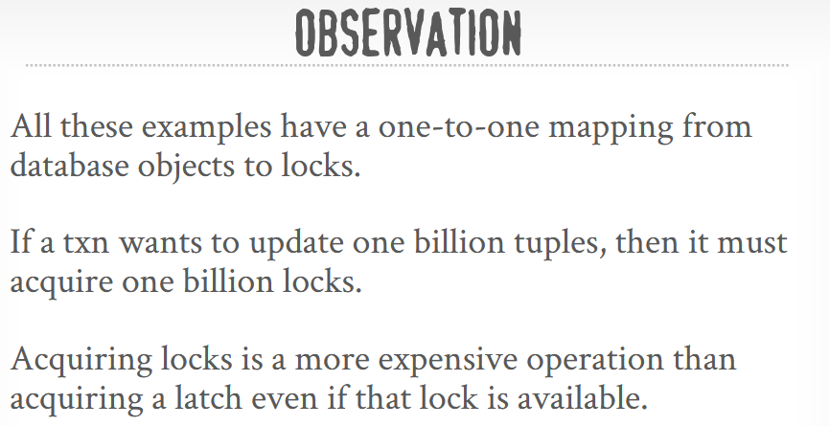

Lock Granularity
Getting a separate lock for a billion individual pieces of data is incredibly slow, but locking an entire table just to change one item stops other transactions from working at the same time. To balance this, databases use a lock hierarchy, ranging from large items like whole tables down to specific rows. Locking a large container automatically locks everything inside it.
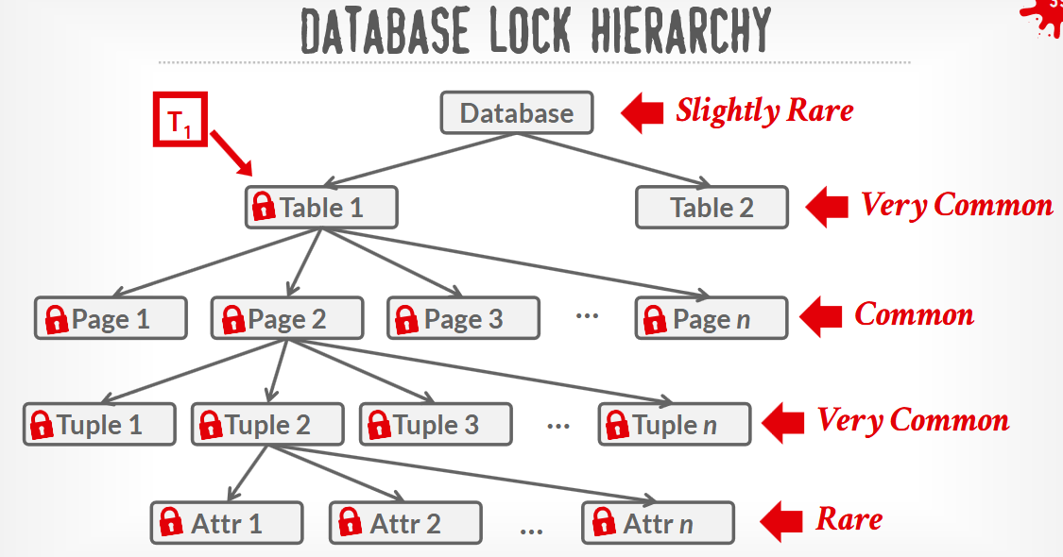
When a transaction locks a small, specific item, it places an "intention lock" on the larger containers above it. This acts as a warning sign, preventing other transactions from accidentally locking the whole table while someone is working inside. These warning signs tell others whether the underlying work involves reading, writing, or a mix of both. If a transaction ends up grabbing too many small locks, the system can automatically upgrade them into one large lock to save effort and speed things up.
